

**DIGHTON ELEMENTARY**

**PRINCIPAL’S MESSAGE**

Dr. Paula Manchester Ashley Fullen

Principal Assistant Principal

**February 3, 2017**

Happy February!!! According to Punxsutawney Phil we have six more weeks of winter. Dighton Elementary School staff and students have been working hard staying on our path toward success. We continue to work toward our district aligned goals of improving student achievement, a safe and positive school environment, using data to make decisions, and integrating technology in our classroom. Over the next couple of weeks, grade level teams will be working together analyzing student data and creating intervention groups based on information they have gained from assessments administered over the last few weeks. RTI/WIN (Response to Intervention/What I Need) continues to be utilized at every grade level to make sure all students are being provided with what they need. I will be sharing school wide assessment data in next month’s newsletter to help inform parents on how we are doing as a school. Please continue to communicate with your child’s teacher if you have any questions about their specific progress.

I wanted to remind parents and community members that one of our School Improvement Goals is to **“create a safe and caring school environment and makes effective use of a system for addressing the social, emotional, and health needs of its students through educational programming that fosters and promotes culture and awareness”.** As we continue to reflect on our social emotional learning and incorporating more cultural learning opportunities, here are some books you can pick up or borrow from the library that immerse children into the lives and cultural experiences of other children.

**Elementary K-4**

* Maya’s Blanket/La Mandta de Maya by Monica Brown
* Drum Dream Girl: How One Girl’s Courage Changed Music by Margarita Engle
* Emmannuel’s Dream: The True Story of Emamanuel Ofosu by Laurie Ann Thompson
* With Books and Bricks: How Booker T. Washington Built a School
* Rosa by Nikki Giovanni
* Ira’s Shakespeare Dream by Glenda Armand
* Four Feet, Two Sandals by Karen Lynn Williams
* Last Stop on Market Street by Matt de la Pena
* My Name is Sangoel by Karen Williams
* Bayou Magic by Jewell Parker Rhodes
* Save Me a Seat by Sarah Weeks and Gita Varadarajan

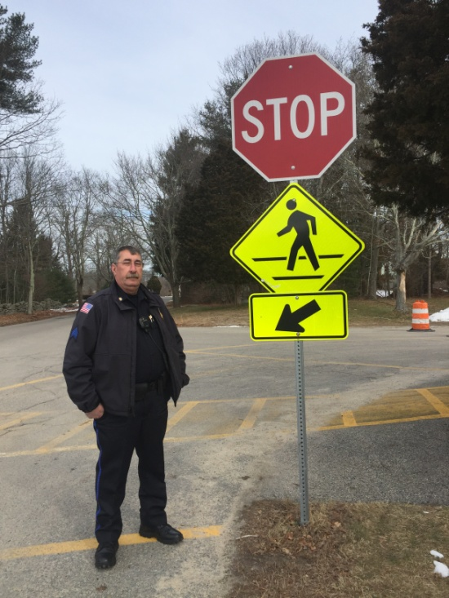

**THANK YOU**

You may have seen the additional two stop signs on our campus. Please remember to stop at the crosswalk AT ALL TIMES. We would like to say THANK YOU to Sgt. Dutra from the Dighton Police Department and Highway Superintendent Tom Ferry who contribute to making our school and school grounds safe. The town of Dighton continues to be a great community because of the commitment from our town agencies. Sgt. Dutra has been a great support to our school community and is always available for a visit, connecting with our students in the hallways, assessing safety in the building, making recommendations to enhance safety, and supporting our safety plans. Sgt. Dutra will be retiring this year and we wanted to thank him for his many years of service in Dighton!

**TLC Gives Back**

Through “Popcorn Thursday” sales, our TLC raised $66.00 for the Retts Foundation. During the month of February, all proceeds from “Popcorn Thursday” will be going to the Ronald McDonald House at Hasbro.

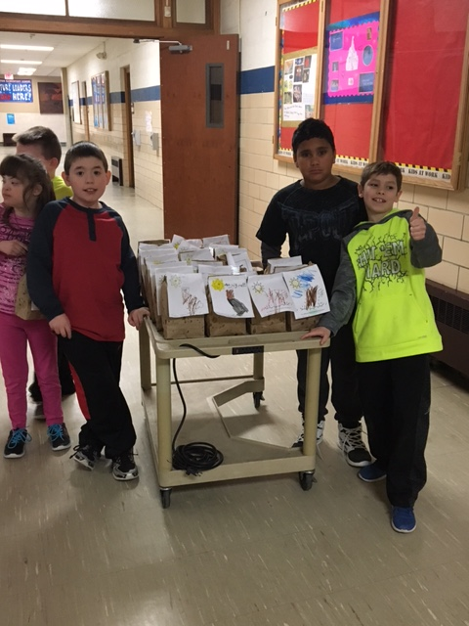

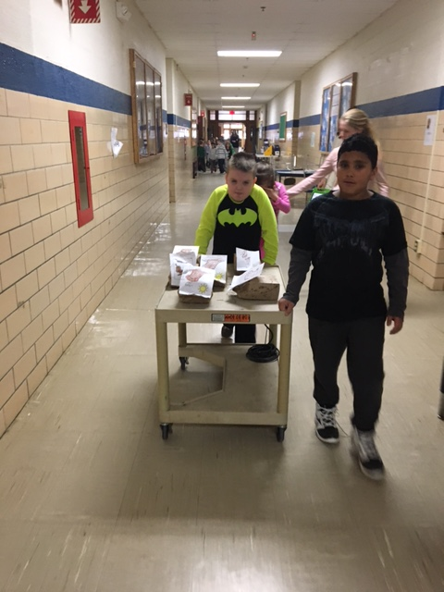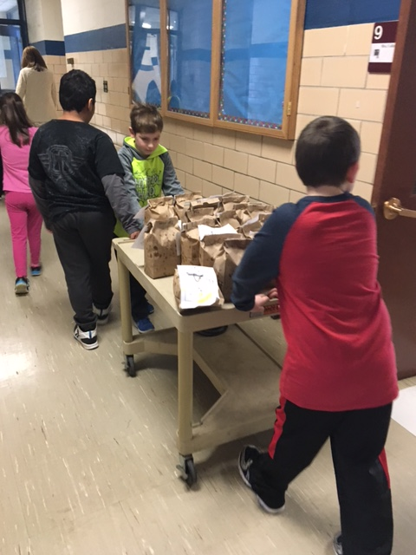

**Eagle Activists**

Our Eagle activists have been very active in the school community over the last couple of months. They were flying around the school in December with loads of projects, we couldn’t have done it without them. Right now “Pennies for Patients” is the focus community service project in progress.  For 3 weeks we are asking DES students to save their change for supporting people with blood cancer.  Money will be collected from classrooms on  1/27, 2/3, and 2/10.  Flyers and boxes have been sent home with students and the coins are rolling in!  Thank you Dighton families for your generosity!  Our first collection looked fantastic!

Our monthly meetings will fall on the second Thursday of every month.  The meeting will be from 3:00 until 3:45.  We will meet in room 16.

Next meeting is Thursday, February 9.

We are still in cold & flu season... 

Just a few friendly reminders…

It is recommended that your child not return to school until they are free from:

1. **Fever** more than 100.4 degrees within the last 24 hours (must be fever free without the use of Tylenol / Motrin)
2. **Vomiting or continuous diarrhea** within the last 24 hours.
3. **Continuous coughing** not relieved with cough medicine.
4. **Conjunctivitis (pink eye)** until treated with prescription medication for 24 hours.

We would greatly appreciate your assistance in preventing the spread of germs and illness in our school. Please help us teach your children good health habits to protect themselves as well as others:

1. Encourage plenty of rest, fluids and nutritious foods.
2. Do not share the same utensils or drinking containers.
3. Cover your mouth and nose when coughing or sneezing into a tissue or into the bent of your elbow.
4. Practice frequent hand washing with soap and water or use hand sanitizer if you are not able to wash. *Hand washing is the best way to prevent the spread of germs!*

Please see the attached link for more information regarding colds and flu from the Center for Disease Control and Prevention. Thank you!

<http://www.cdc.gov/flu/pdf/freeresources/updated/fluguideforparents.pdf>

**IMPORTANT**

[](https://www.bing.com/images/search?q=peanut+free&id=2279E4CCF1F89A7E532378371EAE0B9C36D0CDC9&FORM=IQFRBA)**Peanut and Nut Free Classroom**

**Students in nut-free classroom are NOT allowed to bring peanut or nut products into class at all.  Peanut/nut products are never consumed in the nut-free classroom. Snacks must be peanut/nut-free snacks.  Snacks should come pre-packaged so that ingredients are clearly listed for the teacher or nurse to read. If you send your child in with a baggy of chips, cereal, or other items that have been taken from the original box, it is impossible for the school to determine if the food item may contain nuts. Thank you for your cooperation.**

**“ONE CALL”**

Some of you may have received an automatic “One Call” if your child was

absent. Please call in your child’s absence and leave a message at 508-669-4245 extension 1104. If we do not receive notification about a child’s absence, you will receive a “One Call”. As always, please speak to Mrs. Alberto if you have any medical needs that you need to share with us.

**SNOW**

If it does snow, our students will have an opportunity to enjoying the snow if they have the proper attire. Please send students to school in their snow gear (snow pants, water proof gloves, hats, winter jackets, snow boots).

**Snow Rules:**

All students have outside recess. Students go outside to play each day unless there is rain, heavy snow with hard wind, and/or a wind-chill factor below 20º. If there is more than 3” on the ground snow boots, snow pants and gloves are required in order to play in the snow at recess time. If there is less than 3” students must have snow boots, but do not need snow pants, in order to run around in the snow, but they must not kneel down or roll in the snow. The snow boots must be boots that are waterproof and a child can change before and after recess. All items worn for snow should be items that a child can get in and out of independently.

* Children who are fully and properly dressed for snow can make snowmen and kneel/play in the snow. (water-proof pants, boots, gloves, hat and jacket)
* Children must wear snow boots in order to walk in the snow under three inches.
* Children wearing regular shoes or footwear that is not waterproof-will need to stay on the blacktop.
* Sometimes playground equipment will be off limits if it is covered in snow or ice, to prevent slips and falls. Students are not allowed to play on tall snow banks for safety
* Students are never allowed to throw snow:

a. on the way to or from school or at a bus stop.

b. at school.

Please check temps before school to make sure to send children with the appropriate attire for recess!

**Reading 20 Minutes a Day**

One way to help support the work we are doing here at school is to encourage your child to read daily. As students build their reading fluency and comprehension skills, we need all students to be reading between 15 to 45 minutes each night (depending on their grade level). Reading fluency skills are important to master during the early elementary years, as it will help them to become fluent writers. Fluency and Comprehension also play an important role in math, science and social studies. By making sure children read every night starting in Kindergarten, you can help your child cultivate a habit they will need to become a life-long learner. Please refer to the *Why Can't I Skip My Twenty Minutes of Reading Tonight?* Illustration that shows the positive impact reading every night can have on your child's success.

# 20 Minutes a Day: The Positive Effects of Reading Aloud to Children



**DATES TO REMEMBER C:\Users\Owner\AppData\Local\Microsoft\Windows\Temporary Internet Files\Content.IE5\H81GM0K5\MC900156753[1].wmf**

**February 12th- DES Chorus performing at Providence Bruins**

**February 20th-24th**- Winter Break- No School

**March 23rd-** Lifetouch Spring Picture Day

**April 4th-May 26th- ELA and Math MCAS for grades 3 & 4**

**April 14th-21st-** Spring Vacation

**May 29th**- Memorial Day- No School

**June 8th**- End of Year Chorus Concert

|  |
| --- |
|  |

**Communication C:\Users\Owner\AppData\Local\Microsoft\Windows\Temporary Internet Files\Content.IE5\H81GM0K5\MC900434383[1].wmf**

Please feel free to contact your child’s teacher or myself whenever you have questions. Your child’s teacher, however, should be your first contact to address any specific questions or concerns you may have as they may have the information you need. If they are not able to answer your question, feel free to contact me or Mrs. Fullen. Our goal is to ensure good communication between school and home. I send out my monthly newsletters via email every month. We also use email frequently to communicate any information you may need. You can contact any of the staff here at Dighton Elementary School (DES) by using their first initial and their last name followed by @drregional.org. For example, my email is [pmanchester@dregional.org](mailto:pmanchester@dregional.org)

Here are the direct extensions to some of our support staff. Once you dial 508-669-4245 dial the extension:

Nancy Peixoto 1107

Allison Albert0 1103

Nikki Arruda (Cafeteria) 1121

Laurie Silvia 1236

Lou Kulpa 1207

**Lunch**

Please keep lunch accounts updated. Please contact the office if you need assistance setting up your account. If you have not already done so, please ask the office for a form to apply for free or reduced lunch.

**C:\Users\pmanchester\AppData\Local\Microsoft\Windows\Temporary Internet Files\Content.IE5\EVKOX0WN\MC900359157[1].wmfHealth and Wellness**

Please dress your child appropriately for the weather. The children go outside down to 20 degrees, unless the wind chill makes the temperature go below 20 degrees.

**Third grade parents:**

Just a reminder that your incoming third grader needs to have an updated physical exam turned in to health office BEFORE or ON the first day of school 2017-2018 school year. Please call the health office if you have any questions, 508-669-4245 x 1103.

**DISMISSALS:**

Thank you for supporting our dismissal procedure. A friendly reminder to send in a note if you are picking up your child and do not want them to take the bus. Phone calls for requests for dismissal changes should only be used for emergencies. **Requests will not be taken after 1:30 p.m.** Classroom instruction will not be interrupted to let your child know in advance that he/she will be picked up.

**If you are sending in a note for dismissal, please make sure your child’s full name and classroom are indicated.**

*Grade Level Happenings at Dighton Elementary* C:\Users\pmanchester\AppData\Local\Microsoft\Windows\Temporary Internet Files\Content.IE5\UWTOTHZJ\MC900237619[1].wmf

**​TLC (Therapeutic Learning Classroom)**

It hasn’t been a very cold winter so the students in TLC decided to make some ‘snow’ of their own.  One recipe we tried was super easy and all the children had fun playing with it.  All you need to make this at home is 1 cup of baby oil and 8 cups of flour.   The consistency feels more like “moon sand” than snow and will stay good in a sealed bag for at least a week or so of sensory fun.  The children also enjoyed listening to some winter books.  One of the favorites was Snowman at Night and the students did a sequencing activity, as well as, a few snowmen crafts as follow up activities.

Don’t forget that if we do get some snow to send in snow gear with your child.

**Kindergarten**

The 100th day of school and Valentine’s Day is right around the corner.  The Kindergarten celebrates the 100th day with a day filled with activities revolving around the number 100!   We will be making a special T-shirt to wear for the 100th day and use the other shirt for another project later in the school year.  If this is a hardship for your family, then please speak with your child’s teacher.  We would like everyone to be able to participate on February 16th & 17th.  All Kindergarten classes will be celebrating Valentine’s Day with their classmates in the afternoon of February 14th.  Homemade or store bought Valentine cards should be sent in by this date.  During the month of February students are also focusing on fluency with addition and subtraction with facts to 5.  Be sure to practice those facts often, as well, as those tricky sight words.  Students are working hard to apply all their learned skills to reading and writing.  Also, be on the lookout for emails from your child’s teacher in regards to special snow pant and boot days for playing outdoors!

**C:\Users\Owner\AppData\Local\Microsoft\Windows\Temporary Internet Files\Content.IE5\SOD285RN\MC900059122[1].wmfGrade 1**

It’s hard to believe that we’re already approaching February, more than halfway through our school year!

 First grade continues to be a busy hub of learning.  Throughout January and February a penguin theme has been or will be used to address many of our reading and writing standards as well as the next generation science standards.  We have paired reading both fiction and nonfiction text, for decoding, fluency and comprehension skills.  Children have practiced going back into text to find information or to provide evidence to support answers to questions.   With varying levels of independence we have practiced two column notes, written narratives, opinion, and informational texts.  By the end of this Unit each student will have been walked through the steps of writing a beginning research project!  All of this while learning some cool facts about penguins and their many adaptations to life particularly in Antarctica.  Many have done or will be doing a science experiment on how blubber helps penguins to survive!

In Math in addition to number sense we are completing a unit on data collection, graphing, and comparing data.  Next we are now moving on to place value and understanding that 87 really means 8 tens, and 7 ones.  By this point in the year all students should have math addition facts to 10 committed to memory.  You can help your child to practice these facts even while just riding in the car.  If your child knows them fluently, move on to subtraction facts, or higher numbers such as to 20!  As always we thank you for continually supporting your child’s education by reading together nightly, and assuring homework is completed and back to school on time.  We thank you for all that you do!

**Grade 2 C:\Users\Owner\AppData\Local\Microsoft\Windows\Temporary Internet Files\Content.IE5\H81GM0K5\MC900088956[1].wmf**

Second grade has been hard at work in January learning about the states of matter in science and Snowflake Bentley. Our experiments/investigations have been centered around the properties of matter (solid, liquid, gas), chemical and physical changes of matter and how they change states. Students continue to work on narrative, informational, opinion and open response writing while using 2 column notes to organize their thinking.

In math, our students have been working on addition and subtraction with regrouping as well as problem solving. Students have also finished their mid-year benchmark testing via STAR reader, STAR math and DIBELS as well as completing an informational writing sample.

In February, students will be working on fairytales and folktales in reading, continuing with subtracting larger numbers and building on problem solving skills. Please be sure students are practicing their addition and subtraction facts at home. Math fact knowledge is essential in your child’s success with second grade math topics.

As a reminder, please make sure your child comes in dressed for outdoor recess at this time of year. ***Hats, gloves and winter coats are essential for enjoying the outdoors***.

We hope everyone has a fun and safe February vacation!!!!

**Grade 3**

When you ask your child about their school day, do often hear the words “I did nothing!” A nightly check-in with your child is a helpful exercise. Take time to ask specific questions about their day and go over the agenda for homework. Organization can be difficult at this age level and many students require the extra assistance. Creating consistent routines at home will allow for positive habits develop.

On a happy note, many third graders have mastered their math facts. Math fluency can be practiced with Xtra math, flash cards, prodigy (online game), and orally in the car to nightly activities. When students are fluent with math facts, skills such as solving word problems, geometry, area & perimeter are more easily established. Thank you for your support!

In addition, it is that time of the year that 3rd grade students begin preparing to take their first standardized state assessment, called the “MCAS,” which stands for the Massachusetts Comprehensive Assessment System.  MCAS refers to a series of tests given to public school students in Massachusetts that measure students’ progress toward meeting state educational standards. Standards are statements of what students should know and be able to do by the time they reach a specific grade level.  Our state requires that third graders take the English Language Arts Reading Comprehension assessment.   Your student will be taking the MCAS in the spring.  More information will be coming home as we get closer.

**Grade 4**

Here are some Fourth Grade Happenings....the 4th grade continues to learn about the United States, landforms, and regions. This month we plan on finishing up the Southeast and moving on to the Mid-West. Below are some site the students will be exposed in order to practice finding research about states. The fourth graders have been practicing stating opinions and supporting them with examples and reasons. In math we are beginning to tackle fractions. We are hoping the Patriots will be able to tackle more than just fractions. Go Pats!

[www.50states.com](http://www.50states.com/)

[www.factmonster.com/states.html](http://www.factmonster.com/states.html)

[www.kids.usa.gov/learn-about-the-states/](http://www.kids.usa.gov/learn-about-the-states/)

[www.census.gov/schools/facts](http://www.census.gov/schools/facts)

Reading Specialists

Students throughout the school have recently been reassessed using the STAR Reading and DIBELS assessments. We will be analyzing the data from these assessments to assist us in grouping students most effectively for a new session of RtI (Response to Intervention), to begin this month. The groupings will be flexible, and students' progress will continue to be monitored in the coming weeks. We strongly encourage all students to pick out a good book (or a few!) to dive into over the upcoming school vacation!

~Jenn and Mary Sue

https://ci6.googleusercontent.com/proxy/RnNZfQn2o2xpggJQqefCOervMbPIci5mujDPJnvl43kv6Rtxjyh5gHN_JKVzeU-aaGz3pePFgxfoAAtZJZNx8mveVTc-11j98EfuAJVcumUenA=s0-d-e1-ft#https://ssl.gstatic.com/ui/v1/icons/mail/images/cleardot.gif

**Computers**

*Kindergarten*

The students will be finishing up a coding unit. At the end of the unit, the students will be coding with Bee Bots. These are little programmable plastic toy bees where the student has to put in the code to get it to go to a certain spot on the floor. They will do a lesson in computers but also will be using it within their classrooms. Students will also be using a program called Read/Write/Type to practice with letter location, special keys like the space bar, and using two hands on the keyboard.

*1st Grade*

students will continue to use Read/Write/Type to practice with letter location, special keys on keyboard, and using two hands. In February, students will begin to learn about Google Drive and Google Docs.

*2nd Grade*

Students will continue to work with Google Drive and Google docs. They will be doing some writing that tie back to what they are doing in the classroom. They will also learn how to insert images from the internet into their Google Doc file and how to cite the source.

*3rd Grade*

They will be continue to work with Google Docs. They will also be doing things that tie back to what they are doing in the classroom like take images from the internet on clouds and key historical people that they will be using in the classroom. End of the month, the students will start to learn about how to do research online using note-taking skills.

*4th Grade*

They will be continue to work on researching and how to use note-taking skills. Students during this month will learn about how to use a kid-friendly search engine and how to cite the source of the facts you use online.

**Music **

The DES Chorus will began its second session on Thursday, January 12th. All 3rd and 4th Grade students are welcome to join. Rehearsals will be from 8:00-8:45 every Thursday morning. We will be singing "America the Beautiful" on the ice for the Providence Bruins on Sunday, February 12th!

The 4th Grade students have been learning how to play guitar in music class and will continue through February. I have guitars that the students can use in class, but students are also welcome to bring their own guitar from home if they have one.

The 3rd Grade students will be receiving their recorders when we return from February vacation. I'm looking forward to some happy tooting in the music room!

Don’t miss the End of Year Concert – June 8th

**Kindergarten Screenings**

Kindergarten Screening will be happening during the week of June 5th. Letters with additional information will be going out next month.

**Pre-School Screenings**

ATTENTION PARENTS OF 3 & 4 YEAR OLDS

Call beginning 2/28/17 to schedule a Preschool Screening for the week of March 6-10th

The Dighton-Rehoboth Regional School District is scheduling preschool screenings for the 2017-2018 school year. This screening process is for new applicants who live in the towns of Dighton or Rehoboth and who will be at least 3 years of age by August 31, 2017. These screenings serve two purposes. First, students will be eligible to enter the lottery for available openings in the Integrated Preschool Program. This program integrates typically developing children and children in need of special education services through a play centered, interactive, curriculum rich preschool experience. Secondly, the screenings serve to identify students who may need a variety of special education services.

To schedule an appointment for a screening, please call: 508-252- 5069 **after 2/28**. Calls will be accepted from 12:30 pm – 2:45pm every weekday. You can also leave a message with the number where you can be reached during that time period.

Screening appointments take place at the Dighton-Rehoboth Preschool Program located at the DRRHS facility, 2700 Regional Road, North Dighton during the week of March 6th to March 10th. A developmental and social skills screening will take approximately 45 minutes. Please provide the following items at the appointment:

● Proof of residency (i.e. recent utility or tax statement, lease or mortgage)

● Child’s original birth certificate or certified copy*

● Driver’s license* *copies will be made.

We look forward to meeting you and your child as part of this process. If you have any questions please reach out to us at the School Department

**Dighton PTO**

Questions? Ask us at [dightonpto@drregional.org](mailto:dightonpto@drregional.org) or visit us on Facebook at Dighton PTO

Please check out the new Dighton’s PTO Website at www. DightonPTO.org**.** It is a great website!! They also have a Facebook page. Please “like” it and get updates.

We have a phenomenal PTO that supports us in so many ways. Please support our PTO by attending meetings, volunteering for events, or providing some time and ideas. When you support them, you support our school!!

**DATES FOR 2016-2017**

**PARENT TEACHER ORGANIZATION MEETINGS**

**All meetings are held in the DES library at 7pm. Everyone is welcome!**

**Agendas will be posted prior to each meeting on their website.**

**February 7, 2017  7:00PM**

**March 7, 2017  7:00PM**

**April 4, 2017  7:00PM**

**May 2, 2017  7:00PM**