**Spirit Wear**

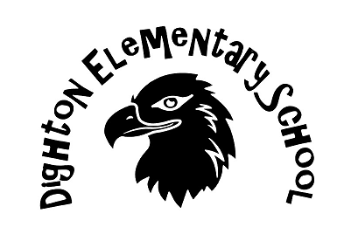

T-shirts – Sweatshirts – Jackets

All items can be embroidered with your child’s name and year of graduation for an extra fee! All order forms are due to front office no later than November 8th and will need to be paid in full to process. Checks to be made out to: DIGHTON PTO. Order form is on the back. We are moving our pick up back to Santa’s Secret Workshop this year on December 7th. If there are any questions, feel free to forward those to: [ptodighton@gmail.com](mailto:ptodighton@gmail.com)

THANK YOU FOR SUPPORTING YOUR PTO!

