[](http://www.google.com/imgres?imgurl=http://www.alphaxidelta.org/clientuploads/AutismSpeaks/AS_10_LightItUpBlueLogo_Horizontal.jpg&imgrefurl=http://www.alphaxidelta.org/news/2012/03/30/march-2012/alpha-xi-delta-to-observe-world-autism-awareness-day/&h=466&w=942&tbnid=3ey6v9f_FY-kIM:&zoom=1&docid=wfz4uNOD6nwBuM&ei=KJsZVf6VCYu0sASeu4HgBg&tbm=isch&ved=0CBoQMygSMBI4ZA)

**C:\Users\pmanchester\AppData\Local\Microsoft\Windows\Temporary Internet Files\Content.IE5\R5W71DH3\flowers-1370674936TDj[1].jpgC:\Users\pmanchester\AppData\Local\Microsoft\Windows\Temporary Internet Files\Content.IE5\R5W71DH3\flowers-1370674936TDj[1].jpgC:\Users\pmanchester\AppData\Local\Microsoft\Windows\Temporary Internet Files\Content.IE5\R5W71DH3\flowers-1370674936TDj[1].jpgC:\Users\pmanchester\AppData\Local\Microsoft\Windows\Temporary Internet Files\Content.IE5\R5W71DH3\flowers-1370674936TDj[1].jpgC:\Users\pmanchester\AppData\Local\Microsoft\Windows\Temporary Internet Files\Content.IE5\R5W71DH3\flowers-1370674936TDj[1].jpgC:\Users\pmanchester\AppData\Local\Microsoft\Windows\Temporary Internet Files\Content.IE5\R5W71DH3\flowers-1370674936TDj[1].jpgC:\Users\pmanchester\AppData\Local\Microsoft\Windows\Temporary Internet Files\Content.IE5\E1JT3RRU\flowers-1370675112B6B[1].jpgDIGHTON ELEMENTARY SCHOOL C:\Users\pmanchester\AppData\Local\Microsoft\Windows\Temporary Internet Files\Content.IE5\R5W71DH3\flowers-1370674936TDj[1].jpgC:\Users\pmanchester\AppData\Local\Microsoft\Windows\Temporary Internet Files\Content.IE5\R5W71DH3\flowers-1370674936TDj[1].jpgC:\Users\pmanchester\AppData\Local\Microsoft\Windows\Temporary Internet Files\Content.IE5\E1JT3RRU\flowers-1370675112B6B[1].jpg**

**PRINCIPAL’S MESSAGE**

Dr. Paula Manchester Ashley Fullen

Principal Assistant Principal

**April 4, 2017**

**Happy April!! Even though we only have 14 school days in the month April, we have a packed filled schedule ahead of us. This month our 3rd and 4th graders will be taking their ELA MCAS on computers, and our PTO will be heading up our Book Fair during the last week of April.**

**April is Autism Awareness Month. This gives us the opportunity to educate ourselves and share some information with you. Stand with us and help us break down the barrier and stigmas attached to autism.**

**Our fourth grade sleepover was a success. Pictures have been shared on classroom websites. Tomorrow we have Cookie and a Book Night for our K-2 families. Classroom field trip information will be shared over the next few weeks. Enjoy our first full month of spring.**

**Yesterday, during a PBIS assembly, our students sent positive messages to our 3rd and 4th graders who began taking MCAS today. Our Growth Mindset messages were exactly what our students needed before taking the test. We look forward to sharing Growth Mindset with our families. Here are some examples of some growth mindset messages we like to share with our students.**

[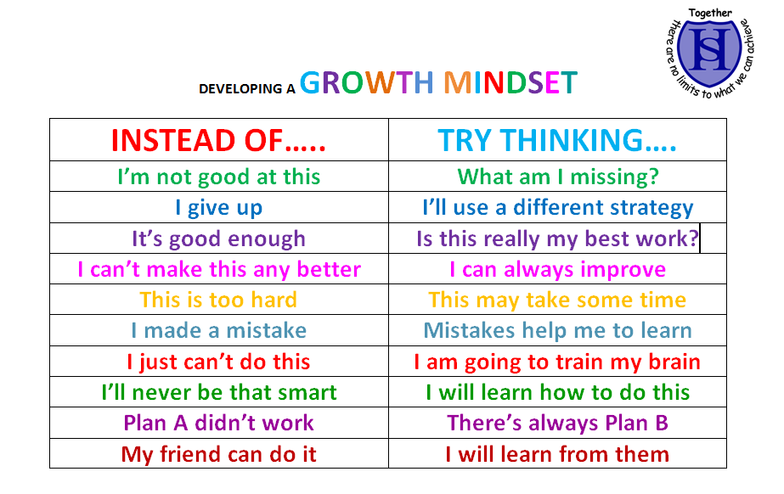](https://www.google.com/url?sa=i&rct=j&q=&esrc=s&source=images&cd=&cad=rja&uact=8&ved=0ahUKEwjYlLjYue7LAhWH0h4KHQzdBiUQjRwIBw&url=https://www.reddit.com/r/GetMotivated/comments/3uc4wy/image_developing_a_growth_mindset/&psig=AFQjCNHQnduR01w7uP2bv1tpAOuMjS0Awg&ust=1459634825390358)



**Dighton Elementary Gives Back**

**Math-A-Thon**

Every grade has been introduced to the Math-a-Thon. Permission slips have gone out and many students have received their booklets. Grade 2 students are getting the grade 3 booklet to do because the grade 2 booklets have not yet arrived. When the new booklets for grade 2 come in, Mrs. Curtis will have them available.

The math is supposed to be fun work to do. Feel free to help your child complete the booklet! I do not need the booklets back. Money will be due April 28th (the last school day in April).

Thank you for your support. St. Jude appreciates all the money we donate each year! I'd love to reach our goal of $6,000.00 this year!

This month’s popcorn collection will be going to The Parkinson's Place.

**DATES TO REMEMBER C:\Users\Owner\AppData\Local\Microsoft\Windows\Temporary Internet Files\Content.IE5\H81GM0K5\MC900156753[1].wmf**

**April 4th-May 26th-** ELA and Math MCAS for grades 3 & 4

**April 5th-** K-2Cookie and Book Night

**April 14th-21st-** Spring Vacation

**April 24th-April 28th**- Book Fair

**May 29th**- Memorial Day- No School

**June 8th**- End of Year Chorus Concert and Spotlight Night

**June 20th**-Grade 4 Duck Tour Field Trip

**MCAS DATES**

|  |
| --- |
|  |

ELA

3rd Grade- April 4th, 6th, and 7th

4th Grade – April 5th, 11th, and 12th

ELA Makeup - April 13th April 24th

MATH

3rd Grade – May 18th and May 23rd

4th Grade- May 22nd May 24th

Math Makeup- May 25th and May 26th

**MCAS**

Our school is administering the Massachusetts Comprehensive Assessment System (MCAS) Reading and Math test to third and fourth graders. This year, students will be taking Computer Based Testing (CBT) which only means it will be taken on the computer instead of paper and pencil.

The MCAS results are important and do provide us with data as we continue to set goals and focus areas here at our school.  However, we do know that it is only one snap shot of what our students know or are able to do. We are very proud of all of our students here at DES and we know that they are bright, kind, creative, and talented individuals. Our goal is always to provide them with the environment to be the best they can be. We continue to want to make this experience as stress free as possible for them. You can help at home by making sure your child:

* Comes to school on time
* Gets plenty of sleep
* Eats a nourishing breakfast
* Knows you believe he/she will do his/her best on the test

I would like to thank all of our students and teachers who have been working hard on preparing for the new CPT. We continue to be fortunate to have the caliber of teaching staff and families that provide our students the needed foundation to be successful.

**Communication C:\Users\Owner\AppData\Local\Microsoft\Windows\Temporary Internet Files\Content.IE5\H81GM0K5\MC900434383[1].wmf**

Please feel free to contact your child’s teacher or myself whenever you have questions. Your child’s teacher, however, should be your first contact to address any specific questions or concerns you may have as they may have the information you need. If they are not able to answer your question, feel free to contact me or Mrs. Fullen. Our goal is to ensure good communication between school and home. I will be sending out my monthly newsletter via email every month. We also use email frequently to communicate any information you may need. You can contact any of the staff here at Dighton Elementary School (DES) by using their first initial and their last name followed by @drregional.org. For example, my email is [pmanchester@dregional.org](mailto:pmanchester@dregional.org)

Here are the direct extensions to some of our support staff. Once you dial 508-669-4245 dial the extension:

Nancy Peixoto, Special Education Secretary 1107

Allison Alberto (School Nurse) 1103

Laurie Silvia (School Adjustment Counselor) 1236

Lou Kulpa (School Psychologist/Sped Coordinator) 1207

**Lunch**

Please keep lunch accounts updated. Please contact the office if you need assistance setting up your account. If you have not already done so, please ask the office for a form to apply for free or reduced lunch.

**Mrs. Alberto’s Message C:\Users\pmanchester\AppData\Local\Microsoft\Windows\Temporary Internet Files\Content.IE5\EVKOX0WN\MC900359157[1].wmf**

**Mylan Recall on Select EpiPen Lots**

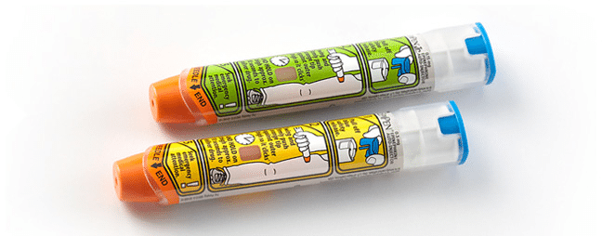

Mylan is recalling 13 lots of Epi Pens after a defect in an injector was found. The recall impacts certain lots of the 0.3mg and 0.15mg strength of EpiPen Auto-Injectros.

Below is a link with affected lot # and contact information for a replacement EpiPen.

<http://www.mylan.com/en/epipenrecall>

ALL EPI PENS KEPT AT SCHOOL HAVE BEEN CHECKED AND WERE NOT FOUND TO BE IMPACTED BY THIS RECALL.

For additional information please contact Mylan Customer Relations at 800-796-9526 or [customer.service@mylan.com](mailto:customer.service@mylan.com)

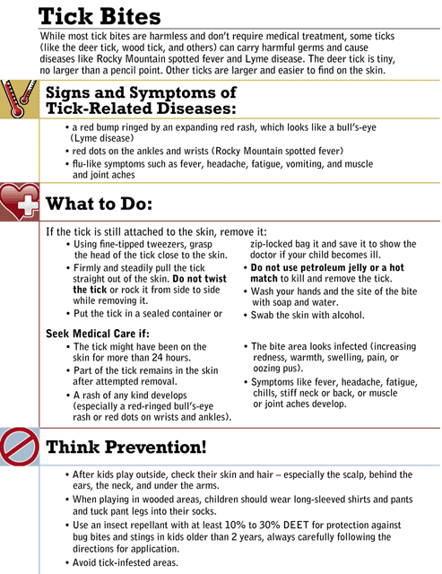

Please see fact sheet from the CDC for additional information.

<http://www.cdc.gov/lyme/resources/toolkit/factsheets/10_508_Lyme%20disease_Outdoorworkers_FACTSheet.pdf>

**DISMISSALS:**

Thank you for supporting our dismissal procedure. A friendly reminder to send in a note if you are picking up your child and do not want them to take the bus. Phone calls for requests for dismissal changes should only be used for emergencies. **Requests will not be taken after 2:00 p.m.** Classroom instruction will not be interrupted to let your child know in advance that he/she will be picked up.

**If you are sending in a note for dismissal, please make sure your child’s full name and classroom are indicated.**

*Grade Level Happenings at Dighton Elementary* C:\Users\pmanchester\AppData\Local\Microsoft\Windows\Temporary Internet Files\Content.IE5\UWTOTHZJ\MC900237619[1].wmf

**Kindergarten**

Spring is in the air throughout Kindergarten! The kindergarten students will be having an egg-cellent time at our Kindergarten Easter Egg Hunt on April 13th. The kindergarten will be celebrating the Qu Wedding on April 13th as well! Please see individual classroom information for details on this special event. Kindergarten students will also have a special visit from DRRHS students.  The high school students will visit during the month of April, read the story The Lorax by Dr. Seuss, and do an activity related to the story.

As the month progresses K students will be working on Student Treasure Books. These books are a great addition to your home library and a wonderful keepsake. Each student gets a page in his or her classroom book, in which he or she is the author and illustrator. Student Treasure Books get published and bound in hardcover. Order forms for the books will be going home shortly.

Spring topics such as animals, planting, life cycles, and warmer weather will be explored throughout April in Kindergarten.  Students will be discussing recycling, nature, growing, and Earth Day.  Classes will be involved in activities to benefit the environment such as creating bird feeders, planting flower/vegetable seeds, and spring cleaning our playground/and classroom.  April is definitely looking bright in Kindergarten!

C:\Users\Owner\AppData\Local\Microsoft\Windows\Temporary Internet Files\Content.IE5\SOD285RN\MC900059122[1].wmf

**Grade 1**

March was out of this world in first grade, literally! In March we explored Earth’s place in our Universe. We observed and read about patterns of the sun, moon, and stars to determine how they affect day and night as well as seasons of the year. This was the focus for much of our reading and writing in the month of March. We practiced accessing non-fiction text to gather information and answer comprehension questions. We reinforced features of non-fiction text. We continued to practice two column notes as a means of organizing information for informational writing. In April we will move on to Living Things with a focus on plants, and how they adapt to their environment. From here we will move on to a study of animal adaptations.

We continued to write narratives as well. We used mentor texts to notice what good writers do, and practiced using a “slamming start” (a topic sentence to lure a reader!). We will continue expanding all writing to include good supporting details and attention to upper case letters, spaces, and end marks.

Math has centered on comparing larger numbers, including adding ten to a number. In April we will practice adding and subtracting tens, as well as making groups of ten as a strategy for adding. Please continue to work with your child on fluently knowing math facts. All children should be able to add numbers to ten fluently (quickly and "without really thinking about it". Happy Spring!

**Grade 2 C:\Users\Owner\AppData\Local\Microsoft\Windows\Temporary Internet Files\Content.IE5\H81GM0K5\MC900088956[1].wmf**

The second graders are working hard. They have all finished a detailed unit on folktales and fairytales. The students really enjoyed using puppets to show what they had learned about the tales they read. The students are also working hard in math. Time and money are our next units of study. Extra help and practice at home would be great! ☺ Even though the students have all finished math work with addition and subtraction, they also need to continue to work on memorizing their basic math facts.

We are beginning to work on an author study with all the students. We hope they find this unit and fun and interesting as the last unit!

Keep your second grader reading at home! We are seeing great growth in reading overall and are very proud of them!

**Grade 3**

Third graders keep up the daily practice of your math facts! It is important to be fluent in addition, subtraction, multiplication, and division facts when preparing and looking ahead to 4th grade. Xtra math, math fact cards, and practicing aloud with a partner will assist in this goal.

Just a reminder that the third graders will be taking the ELA portion of the MCAS test on April 4th, April 6th and April 7th. By working together, we can make your child’s test experience positive and successful. Here are some suggestions you can do to help your child succeed:

o   Make sure your child gets a good night’s rest

o   Have your child eat a healthy, protein filled breakfast

o   Make sure your child arrives at school on time

o   GENTLY encourage your child to do their best

Also, we are asking all parents to write their child an encouraging note and return it to their classroom teacher in a sealed envelope ASAP. SHHHH lets keep it a secret!

**Grade 4**

In ELA, all of 4th Grade has been focusing on a Poetry Unit called Images and Metaphors.  In addition, two of the classes have started our baseball unit, "Negro League Baseball" using the book We are the Ship by Kadir Nelson while the other two classes are working on "Book Clubs", or Literature Circles. The classes look forward to switching these to activities around the end of April. Writing has been a big focus in each of the rooms, too, especially narrative.  In Math, we finished up our Multiplying Fractions Topic and are working on Line Plots and Data. In Science, children are working in groups to construct a windmill. Students are encouraged to bring in items they think may help them with their creation.  In Social Studies we are continuing our road trip around the United States and will be traveling to the Southwest Region.

Please be aware of the following April MCAS dates:  Wednesday April 5th, Tuesday April 11th and Wednesday April 12th. It is especially important for your child to get a good night's rest, have a healthy breakfast, and come to school on time on these days.  Thank you in advance for your support.

Coming up on Monday, April 25th is 4th Grade's Annual Kite Day!  Volunteers with current CORI checks are welcome in the cafeteria at 8:45am.  This is a rain or shine event. A calendar was sent home recently with all of the students outlining our upcoming 4th grade festivities. Here's to a warm and happy Spring for all of our 4th grade families at DES!

**Music and Chorus **

We've been exploring interactive music learning games in music class.   
  
Have fun at home with the fantastic array of activities at: [**pbskids.org/games/music/**](http://pbskids.org/games/music/)

Check out "What Sounds Like What?" and see if you can identify one, two, or even three different instruments playing at the same time.

Go to "The Magical Lyrical Solarium" and create your own songs.

Create your own music and test your listening skills at: [**creatingmusic.com**](http://creatingmusic.com/).

Go to the "Hearing Music" section and test your skills with the "Pitch Game," the "Comparing Game," and the "Pitch & Rhythm Game."

**Library**

Hooray! April is National School Library Month. This year’s theme is *Because School Libraries Empower Students.* In celebration of School Library Month, here is a look at how the Library Media curriculum supports the focus areas of DES:

Student Achievement – Numerous research studies link high standardized test scores with schools that employ a certified librarian. Not only does the library foster greater independent reading that leads to better reading skills, Mrs. Grabke also enforces critical thinking and learning skills that help students complete academic tasks. Recently Mrs. Grabke showed 3rd graders how to skim an encyclopedia article to find facts while 4th graders were taught to use photos in books as clues to where they might find more information on a topic.

Technology – Mrs. Grabke teaches students many of the programs purchased by our school, including Accelerated Reading and Razz Kids, as well as programs offered by belonging to the Mass. Library System and SAILS – such as Britannica Online and Tumblebooks. Students are given an opportunity to explore author websites, the Library of Congress website, and various research sites, such as Fact Monster. Mrs. Grabke also collaborates with Mr. Badger, our technology teacher, in teaching internet searching, avoiding plagiarism and other topics.

Teaching and Professional Development – Mrs. Grabke supports classroom teachers by providing collections of books and collaborating with teachers on research projects and lessons. Some of the books provided for teachers this month include tree books for kindergarten, author study books for first grade, fairy tales for second grade, biographies for third grade and ELA books for fourth grade. Students in fourth grade are currently working on a National Parks research project that is a collaboration among between Mrs. Grabke, Mr. Badger, Ms. Rubano and the fourth grade team.

Safety – Libraries support intellectual freedom by allowing students to explore stories and subjects that interest them. In Library, students can feel safe to learn and explore a wide variety of special interests. In Library, everybody’s opinion is valued and respected so students feel secure expressing and expanding on ideas and concepts, furthering their understanding of themselves and the world around them. In Library, we supplement school curriculum with lessons on literature and information from other cultures so that students learn to respect and accept others. Literature is often used to enhance the building of good character, as we explore themes that include stranger danger, anti-bullying and self-esteem.

For more information on School Library Month, please visit <http://www.ala.org/aasl/slm>.

**Computers**

Kindergarten

Students will be finishing up a unit using the keyboard. The students will start to use their Google Drive accounts. They will also learn how to use Google Draw.

1st Grade

Classes are still working on a Google Docs unit. They will be finishing up some additional sills like adding formatting and bullets within their documents. At the end of month to the beginning of May, the first graders will do some research.

2nd Grade

Students are starting a new Dighton Zoo project. They will be doing research on an animal they would like to be added to this new zoo (pretend). They will be using online resources to gather and collect facts. They will then need to create a Google Slide to showcase their animal facts.

3rd Grade

Students will be taking MCAS CBT during this month on a few days. Students will also be doing some research on Revolutionary War Heroes. They will be learning how to use online encyclopedias and how to collect and gather what you need for research. They will also be learning if a resource is relevant to their research.

4th grade

Students have started their final end of year National State Park projects. They have been put into partner groups. The task is to find facts using specific online resources and nonfiction books that they will need to create a final Google Slides product.

**Physical Education**

The group of 4th grader(Photo) and 3rd graders (Video) who have been working very hard at the jump rope challenge....Bottom left Aiden M jumped rope over 1,000 times today along with a 3rd grader Connor D.  Connor is wearing a blue and green shirt in the video......AMAZING

**https://drive.google.com/a/drregional.org/file/d/0B2vhru8ygWXXSGdBYXNBODNySDQ/view?usp=drive_web**

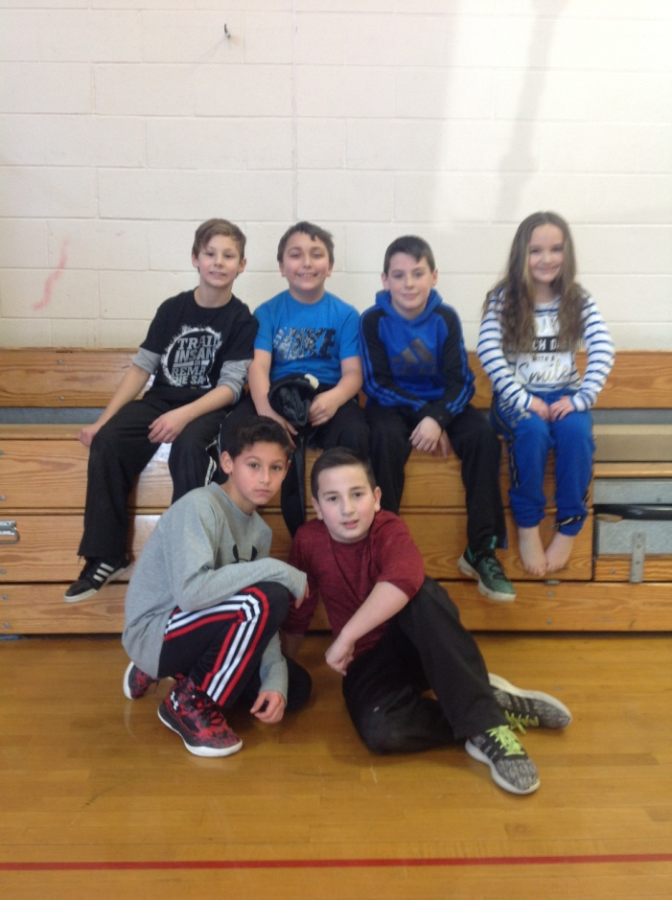

**PTO**

**Dighton PTO**

Questions? Ask us at [dightonpto@drregional.org](mailto:dightonpto@drregional.org) or visit us on Facebook at Dighton PTO

Please check out the new Dighton’s PTO Website at www. DightonPTO.org**.** It is a great website!! They also have a Facebook page. Please “like” it and get updates.

We have a phenomenal PTO that supports us in so many ways. Please support our PTO by attending meetings, volunteering for events, or providing some time and ideas. When you support them, you support our school!!

**DATES FOR 2016-2017**

**PARENT TEACHER ORGANIZATION MEETINGS**

**All meetings are held in the DES library at 7pm. Everyone is welcome!**

**Agendas will be posted prior to each meeting on their website.**

**April 4, 2017  7:00PM**

**May 2, 2017  7:00PM**